**Appendix D. Python code**

The study considers Python as an application to establish the forecasting model and implement the external parameters such as vaccination rate, covid-variant, and control measures into the final model. The following figures describe the detailed code, explanation of the code is directly provided next to the coding sentences:

1. Import libraries into Python file:

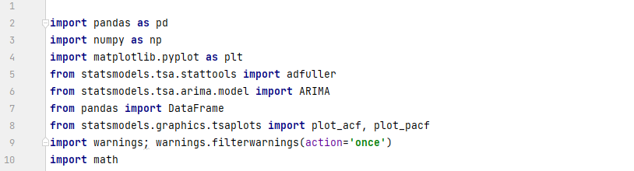

1. Import excel file, this excel file contains the COVID-19 confirmed cases have been recorded daily from 27th April to 24th November 2021. After which, the data was plotted in order to visualize the distribution of the collected data

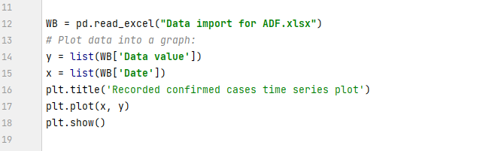

1. The first step in model ARIMA development is considering whether the data is stationary. Hence, an ADF test is provided in the code. From which, d parameters will then be determined based on the stationarity of data in which differencing stage. The COVID-19 confirmed cases in this study is considered to be stationary on the first differencing, which means d = 1 in ARIMA model:

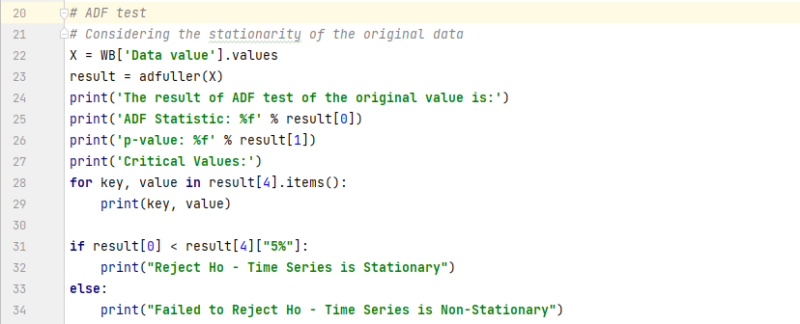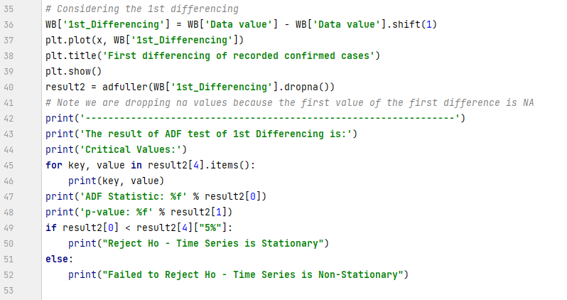

1. AR(p) and MA(q) were determined using ACF and PACF method, the code is as following:

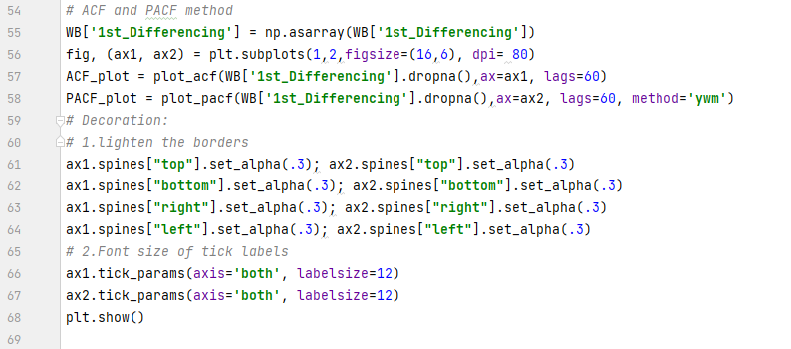

1. To implement the external parameters into the model, the study uses Pearson’s correlation to determine the relationships between Confirmed cases and external data defined. However, since the correlation can easily be calculated through excel, the following code only considers when the Beta parameters of external data have been defined and implement these parameters into the ARIMA model for simplicity:

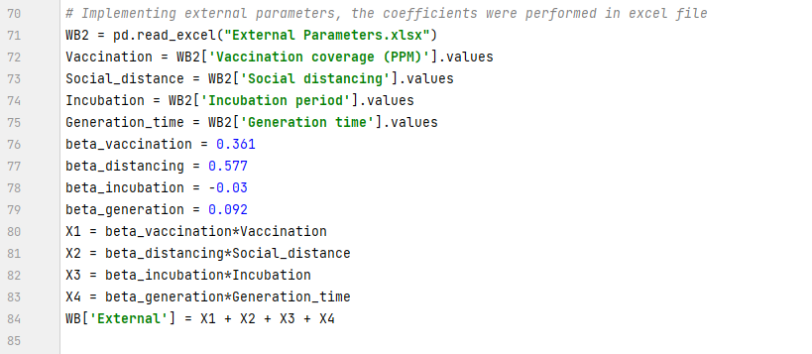

1. The ARIMA parameters and external parameters were used to forecast the COVID-19 confirmed cases in this stage, the following code provides a way to plot these data and include the real data for fitting. Noted that in this stage, a 95% confidence level is applied for COVID-19 confirmed cases collected

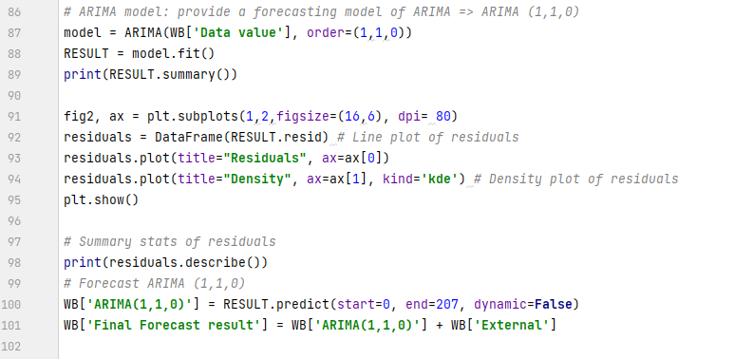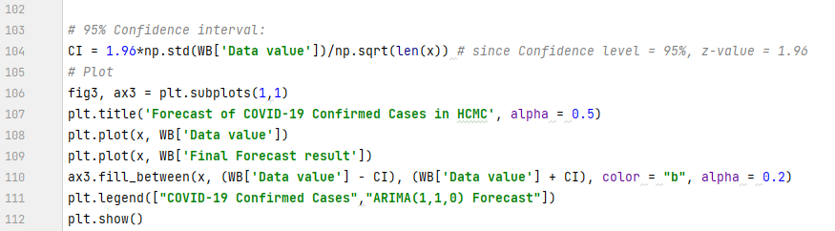

1. After providing forecast results, the study continued with calculating and plotting a 7-day moving average between forecasting results and real data. MSE and RMSE calculation was also included in this part for error comparison in this study:

